# Covid 19 Data analysis

## Load the covid 19 data into a spark data frame (country_wise_latest.csv) with the correct schema definition.

## 

## The are some column names which are long, contains special characters, spaces etc. Rename all such column names accordingly. Example Country/Region - > country New cases - > New_cases etc

### Schema

## Count and check if there any null values in any of the columns

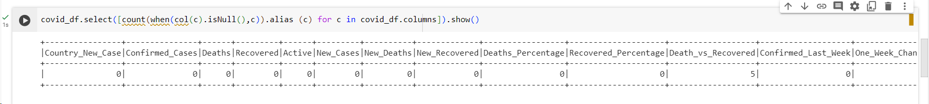

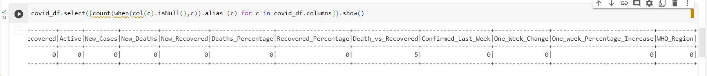

## What are the top 10 countries under the WHO region with covid 19 Confirmed cases

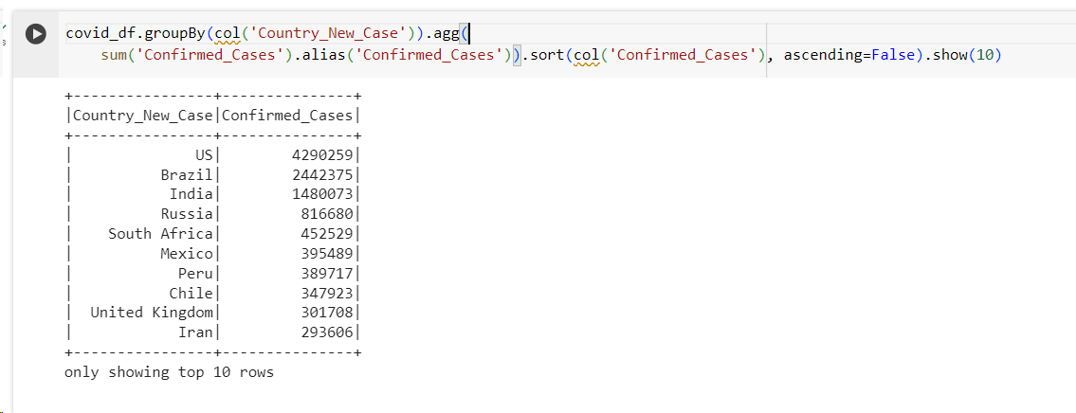

## What are the bottom 10 countries under the WHO region with covid 19 Confirmed cases

## What are the total number of countries/ total no. of WHO regions and also list the various WHO regions

### Total no of countries

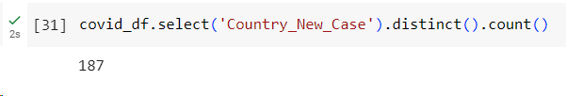

### Total no. of WHO regions

### List the various WHO regions

